

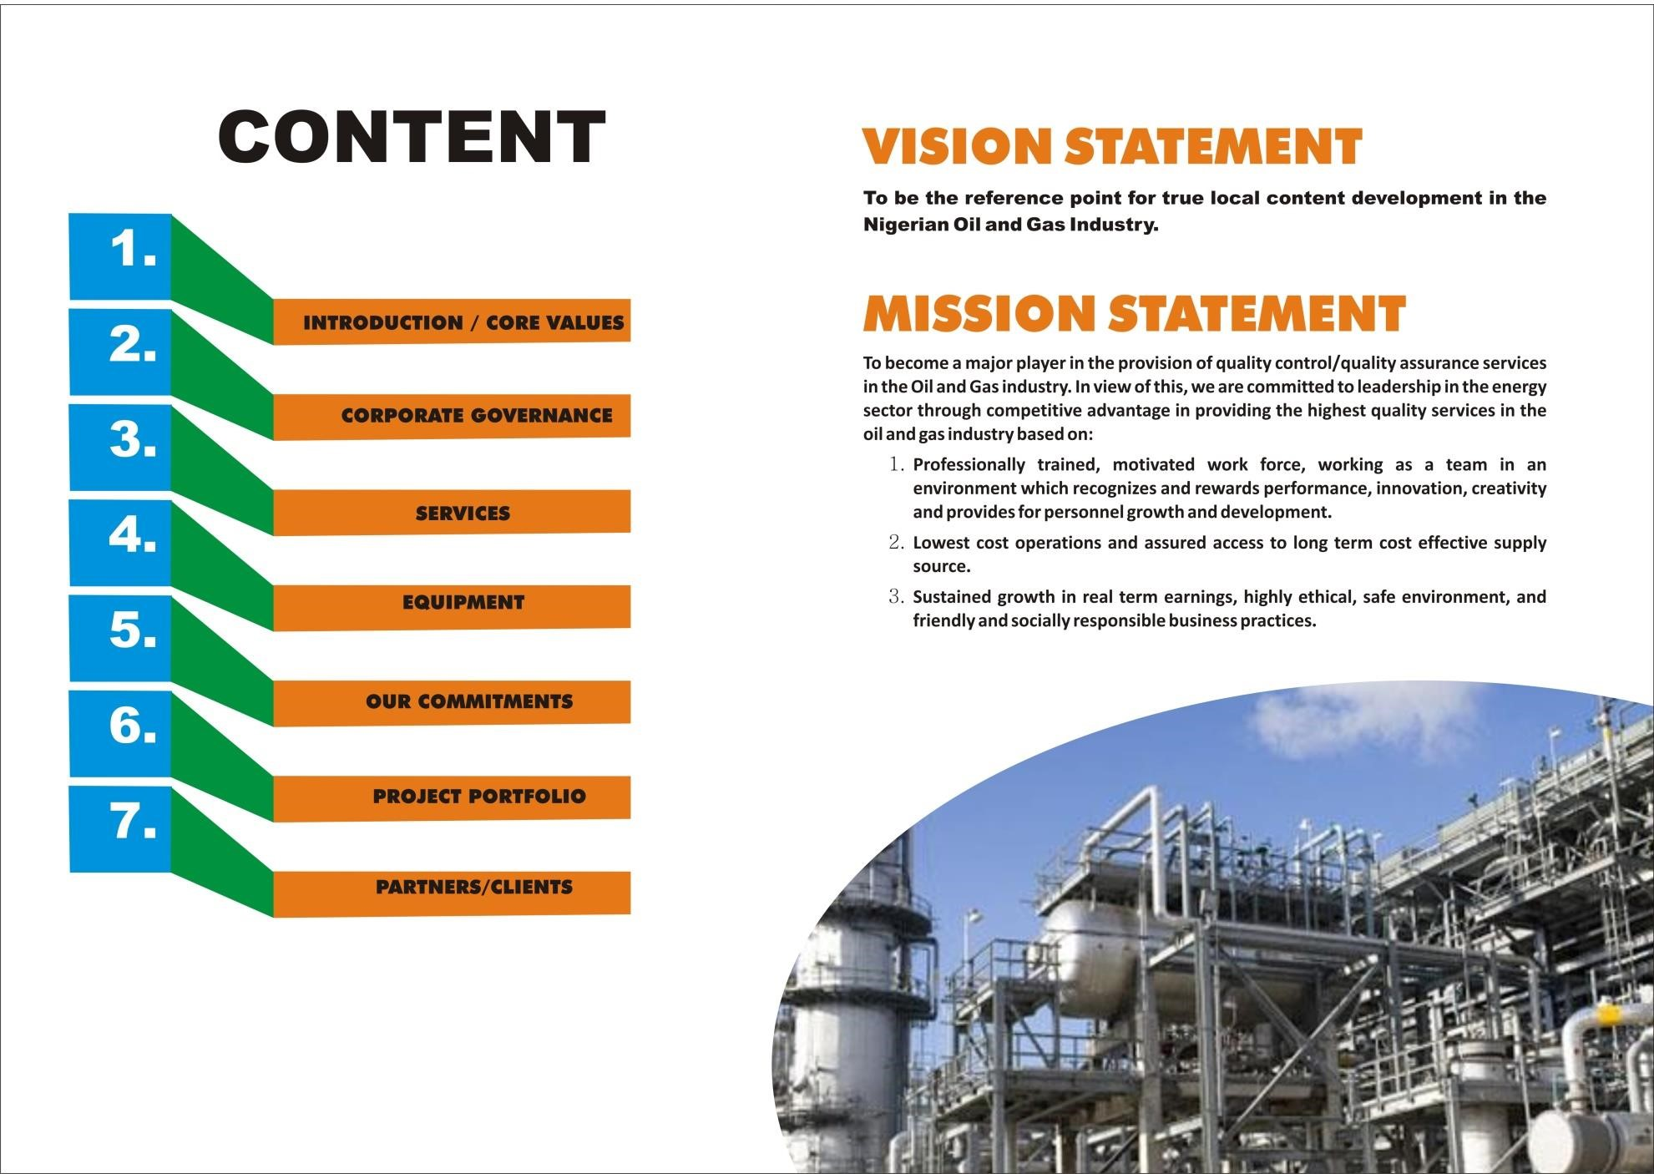

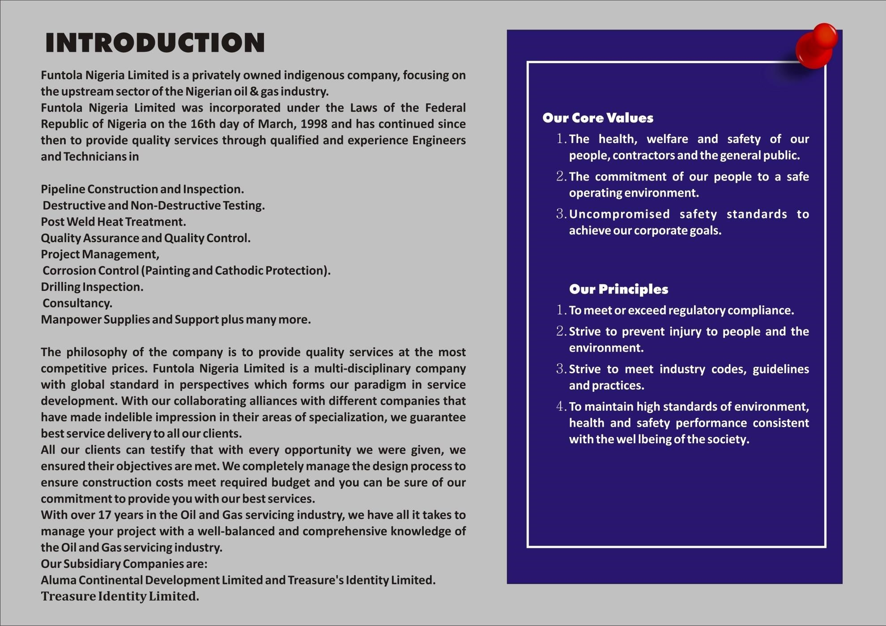
Pipeline Security and monitoring

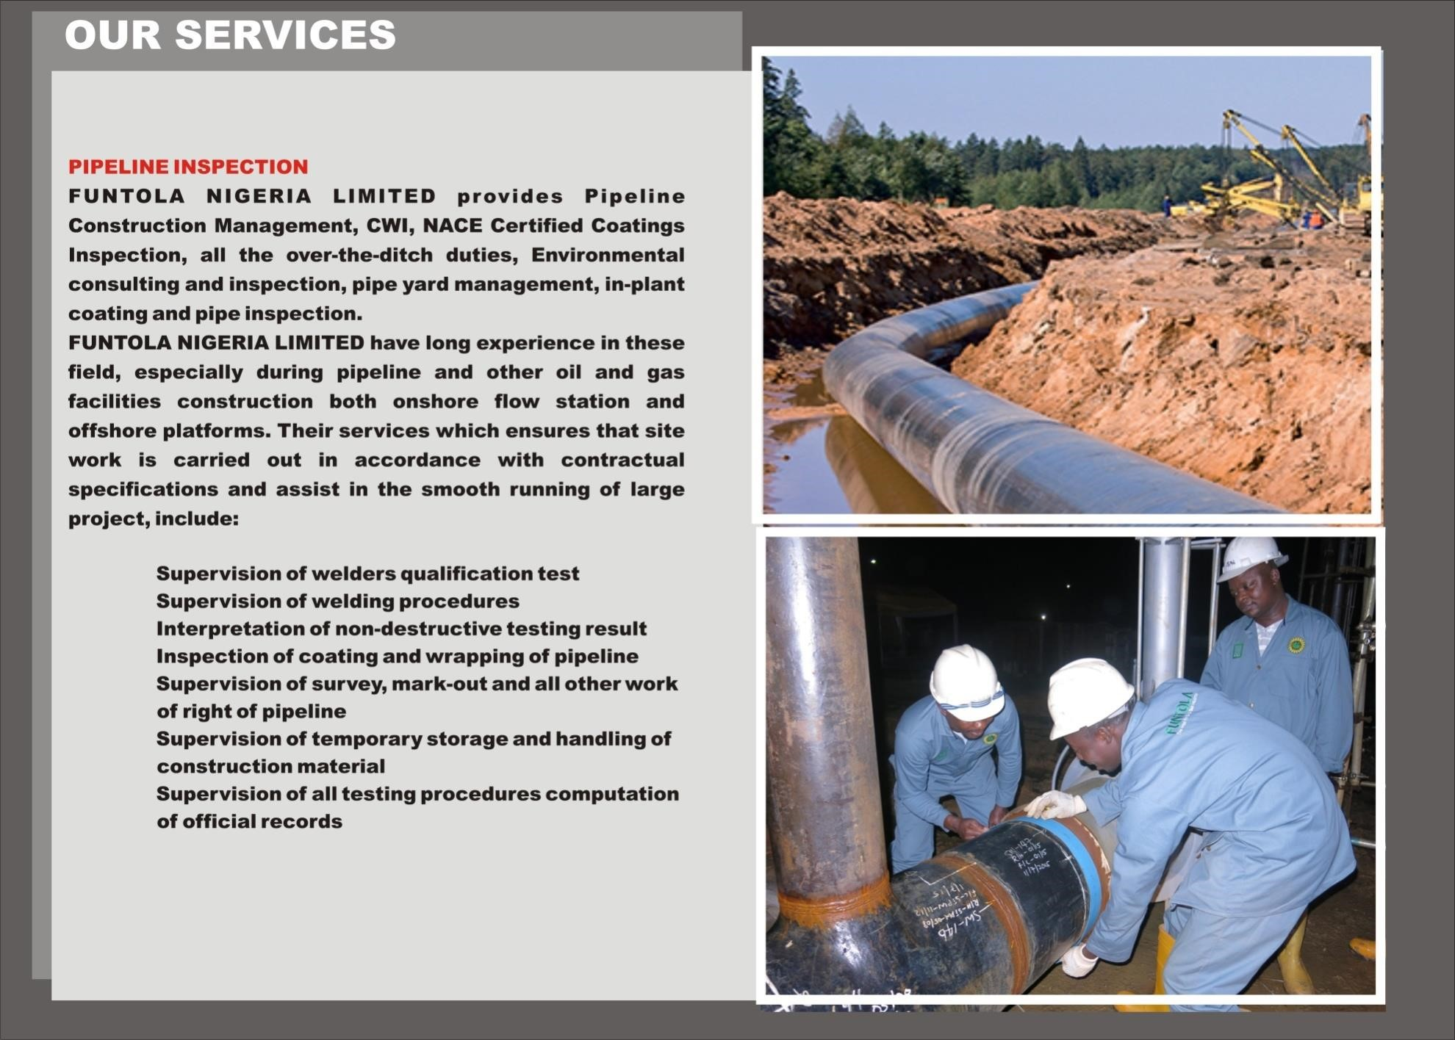

PIPELINE/FACILITIES CONSTRUCTION
, INTERGRITY
TESTING AND INPECTION

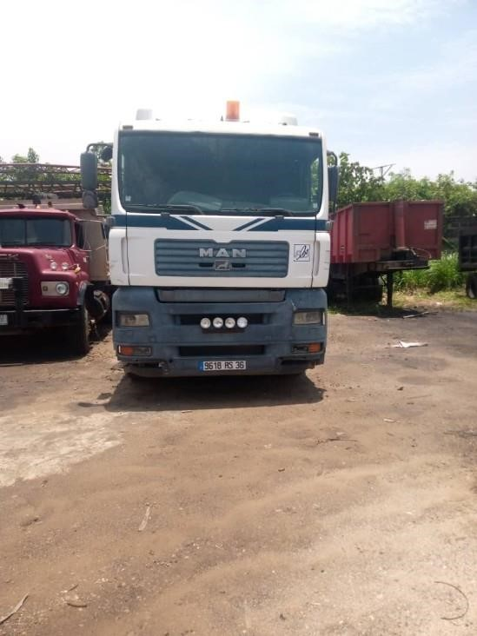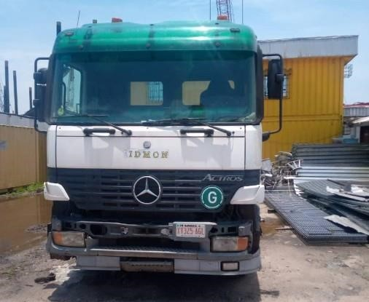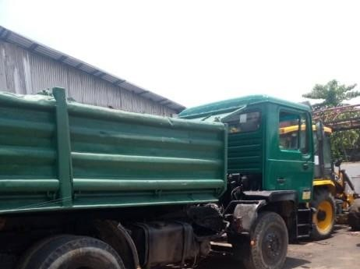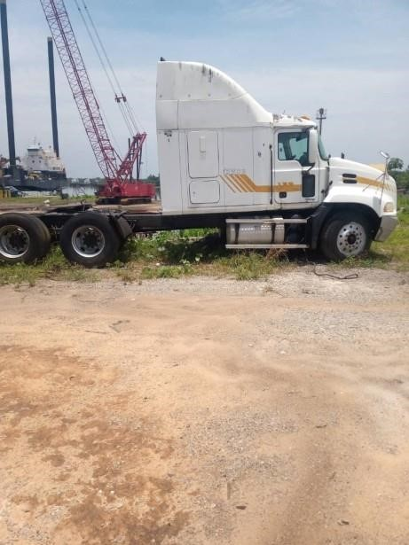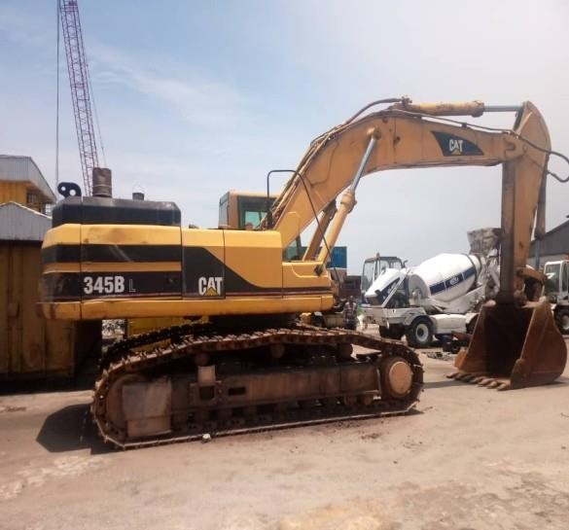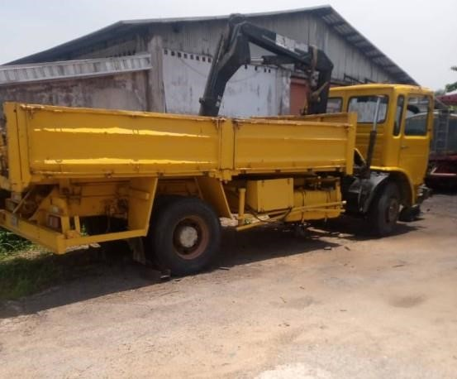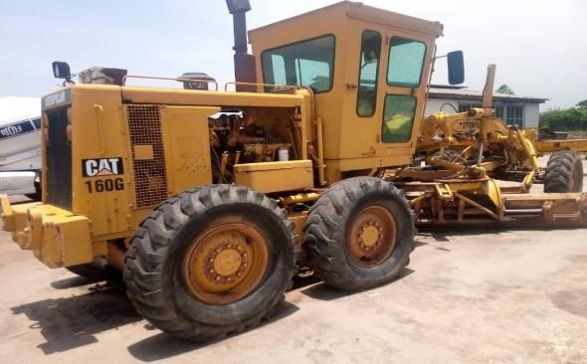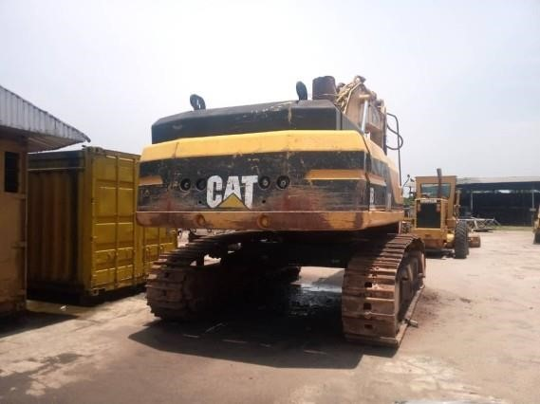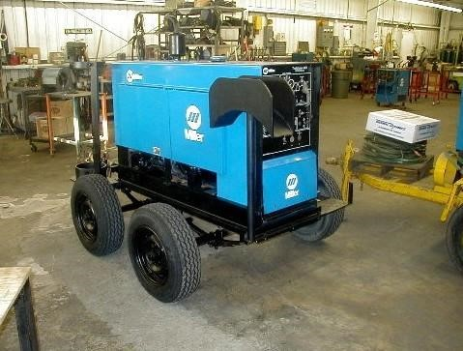

EARTH MOVING VEHICLES

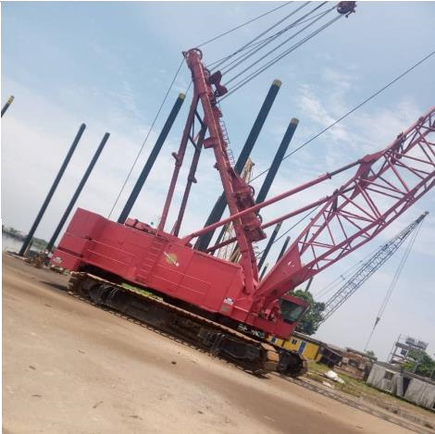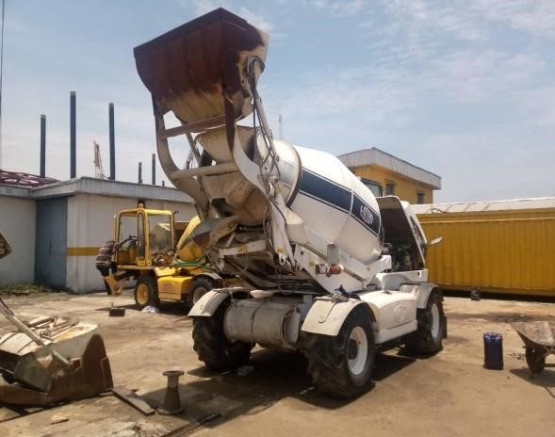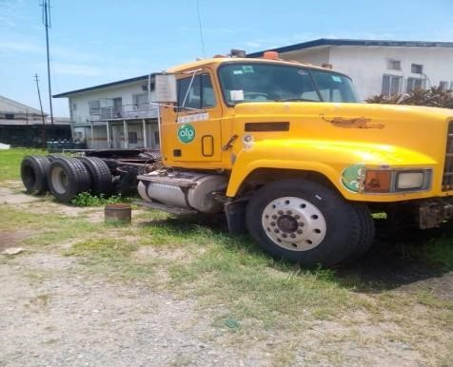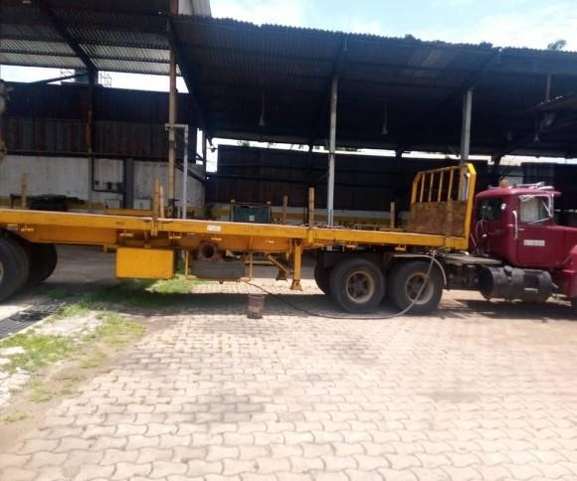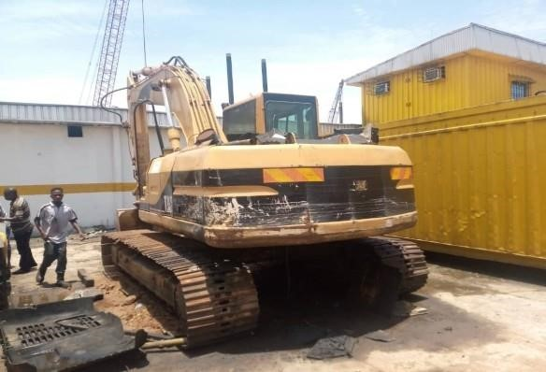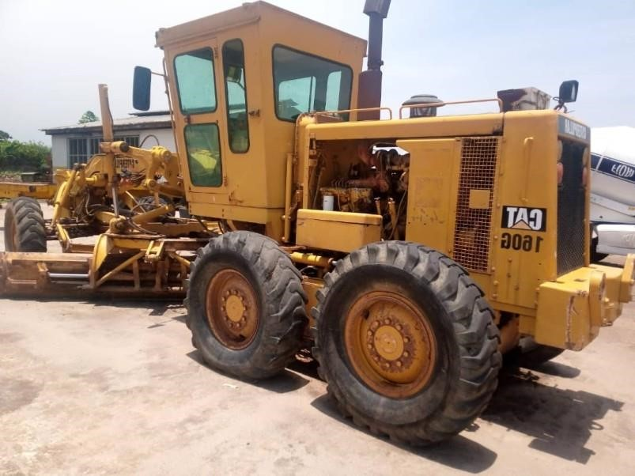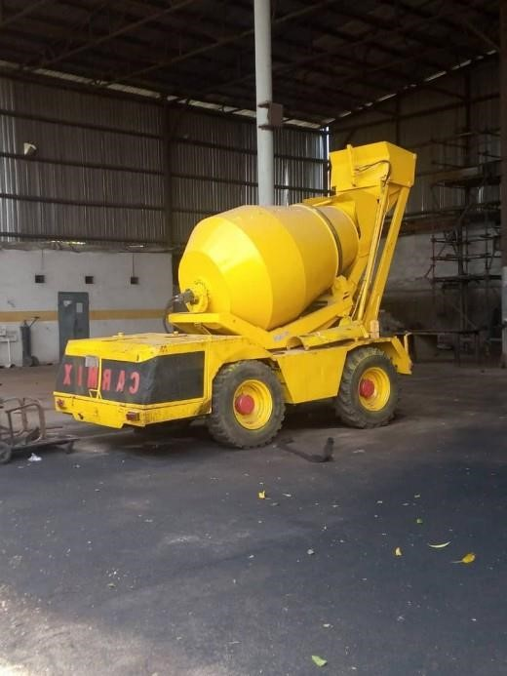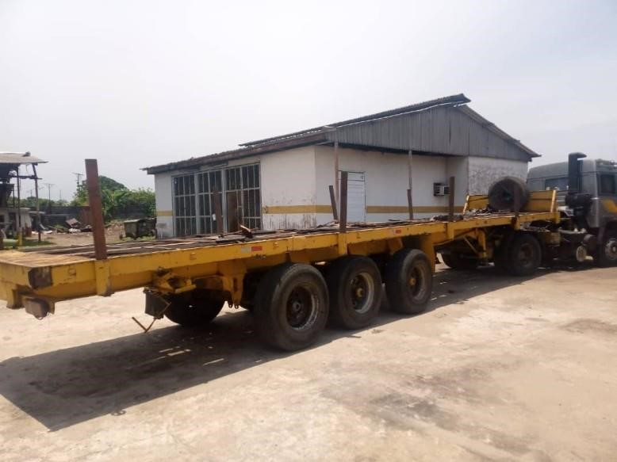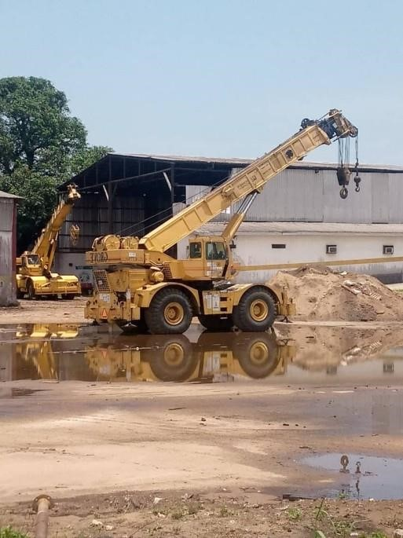

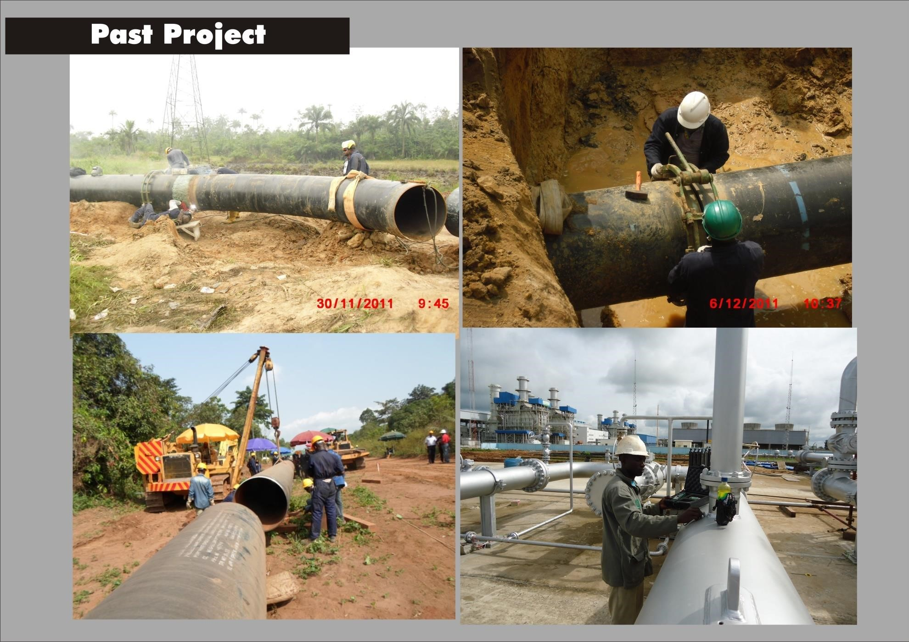

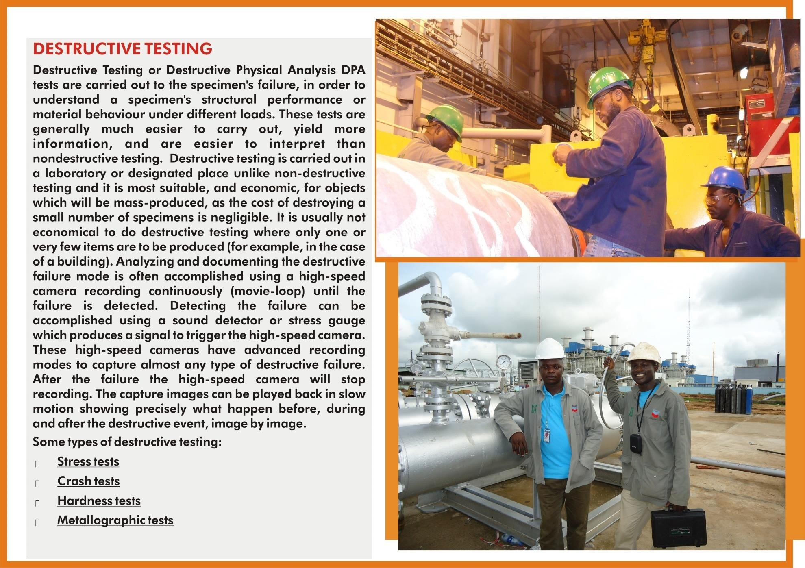

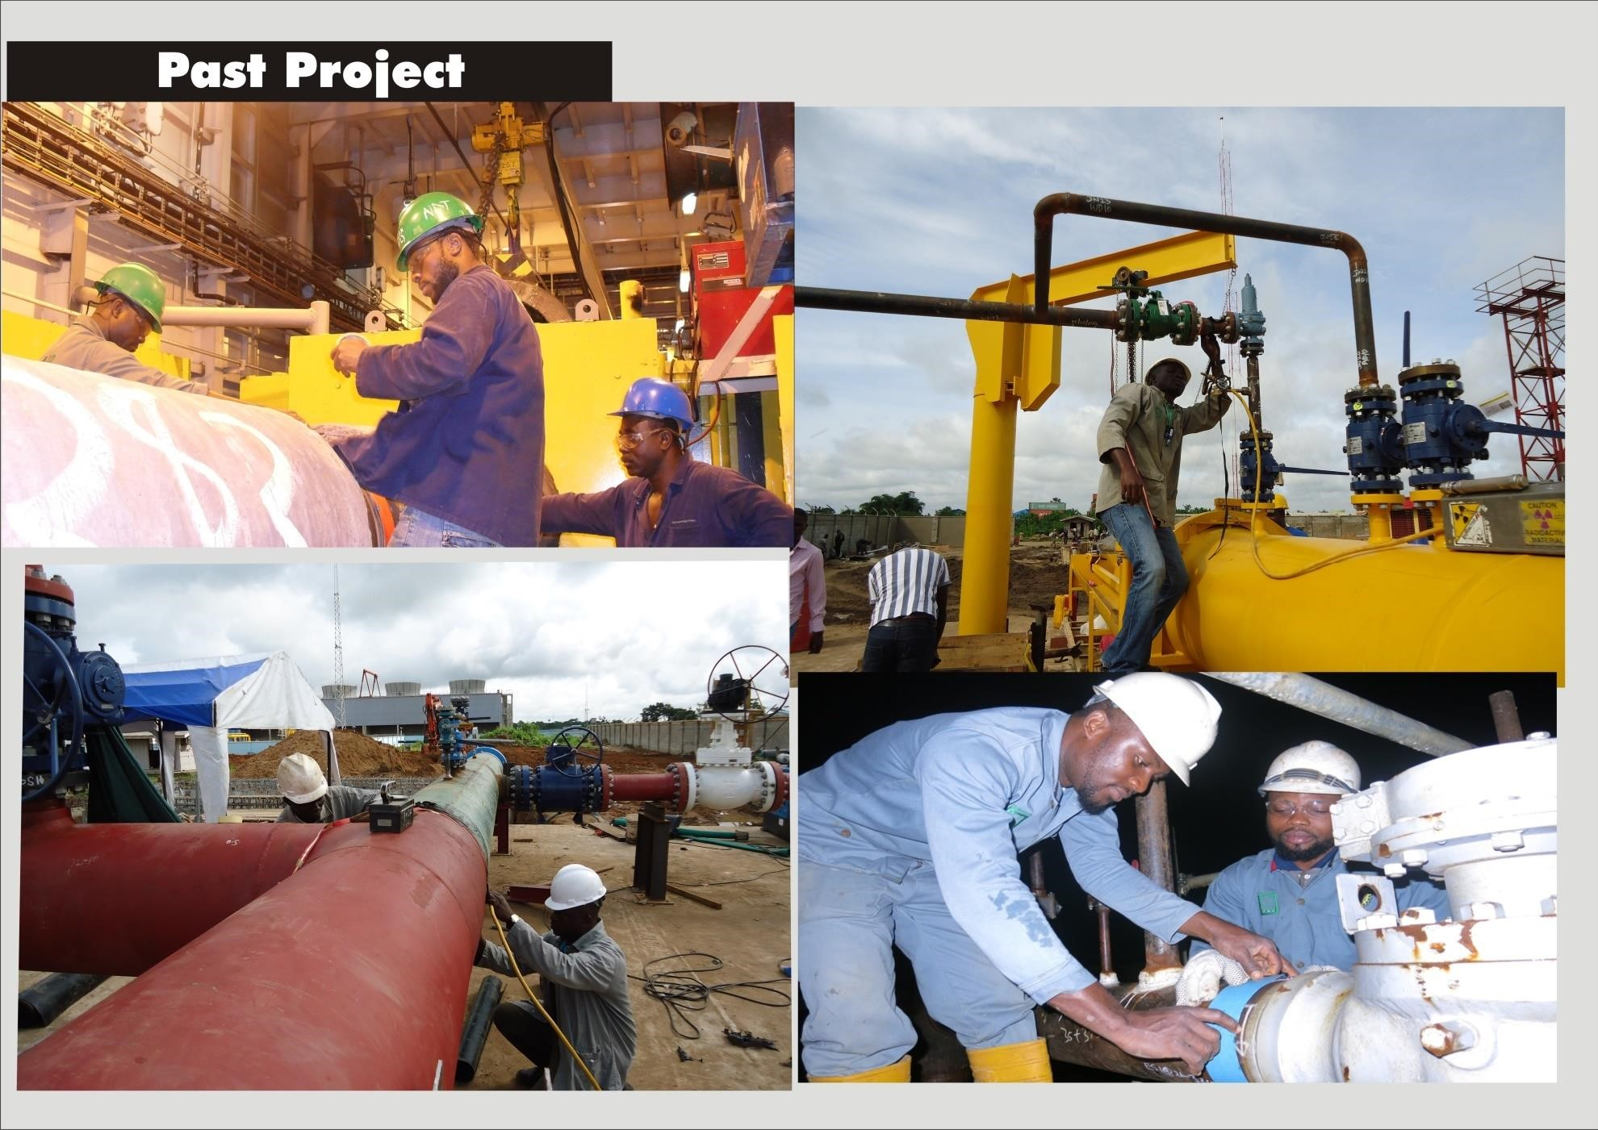

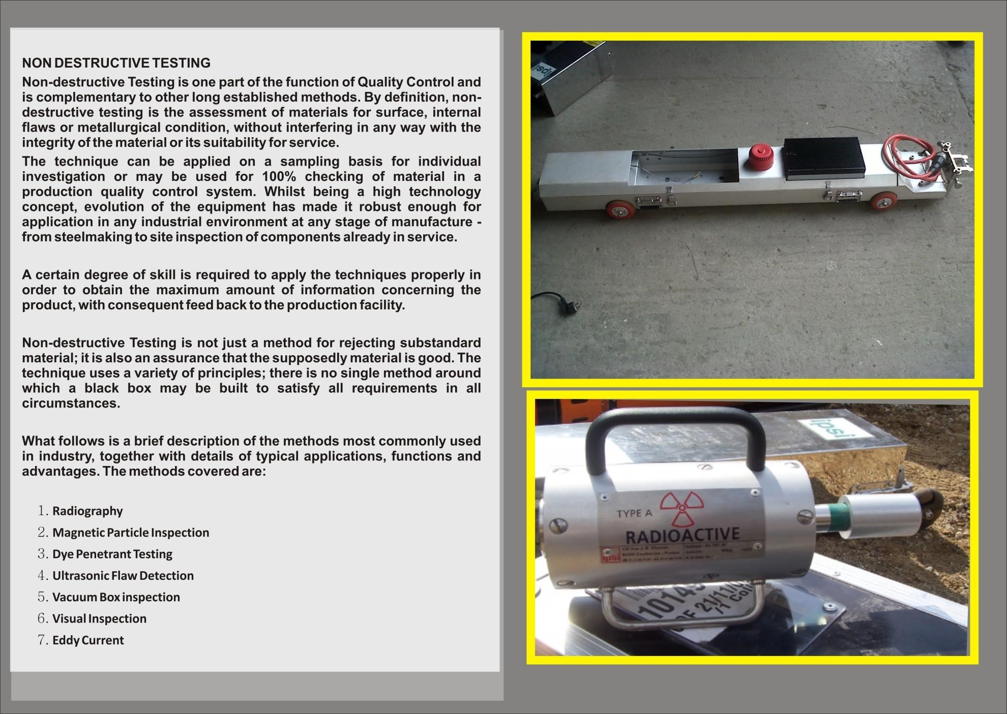
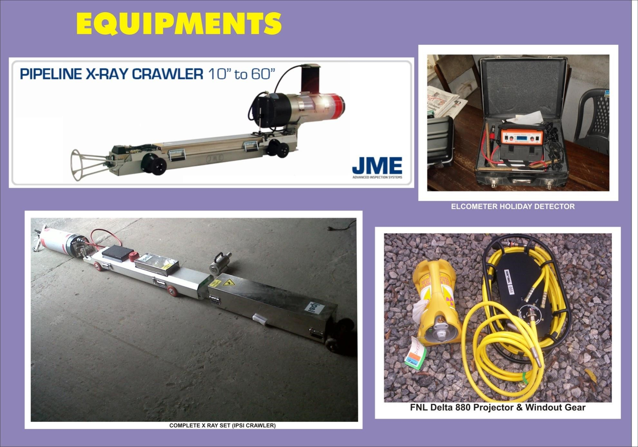

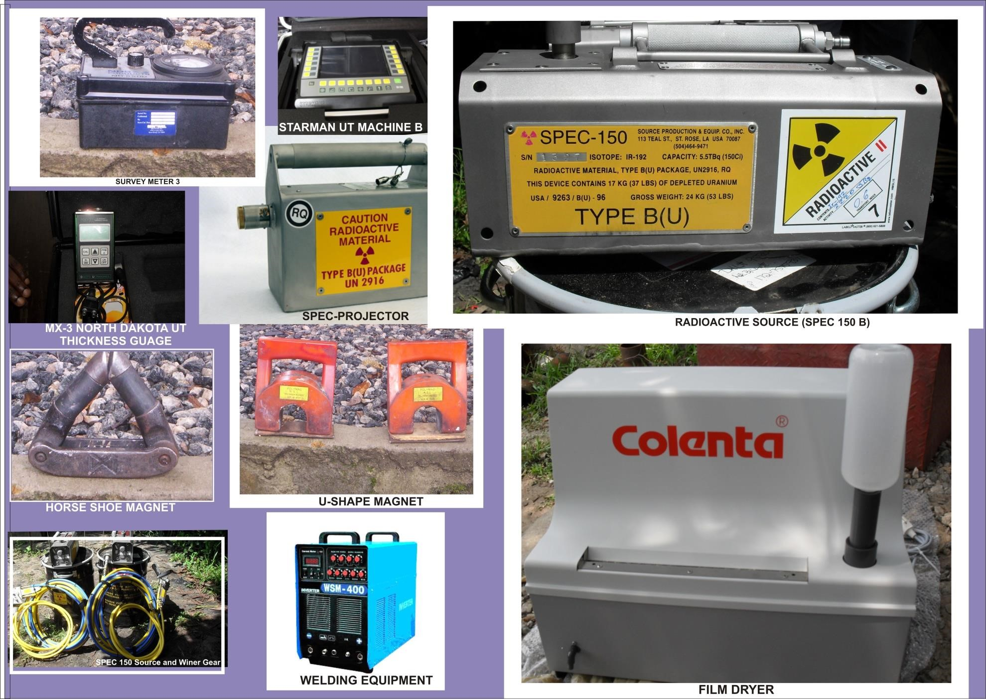
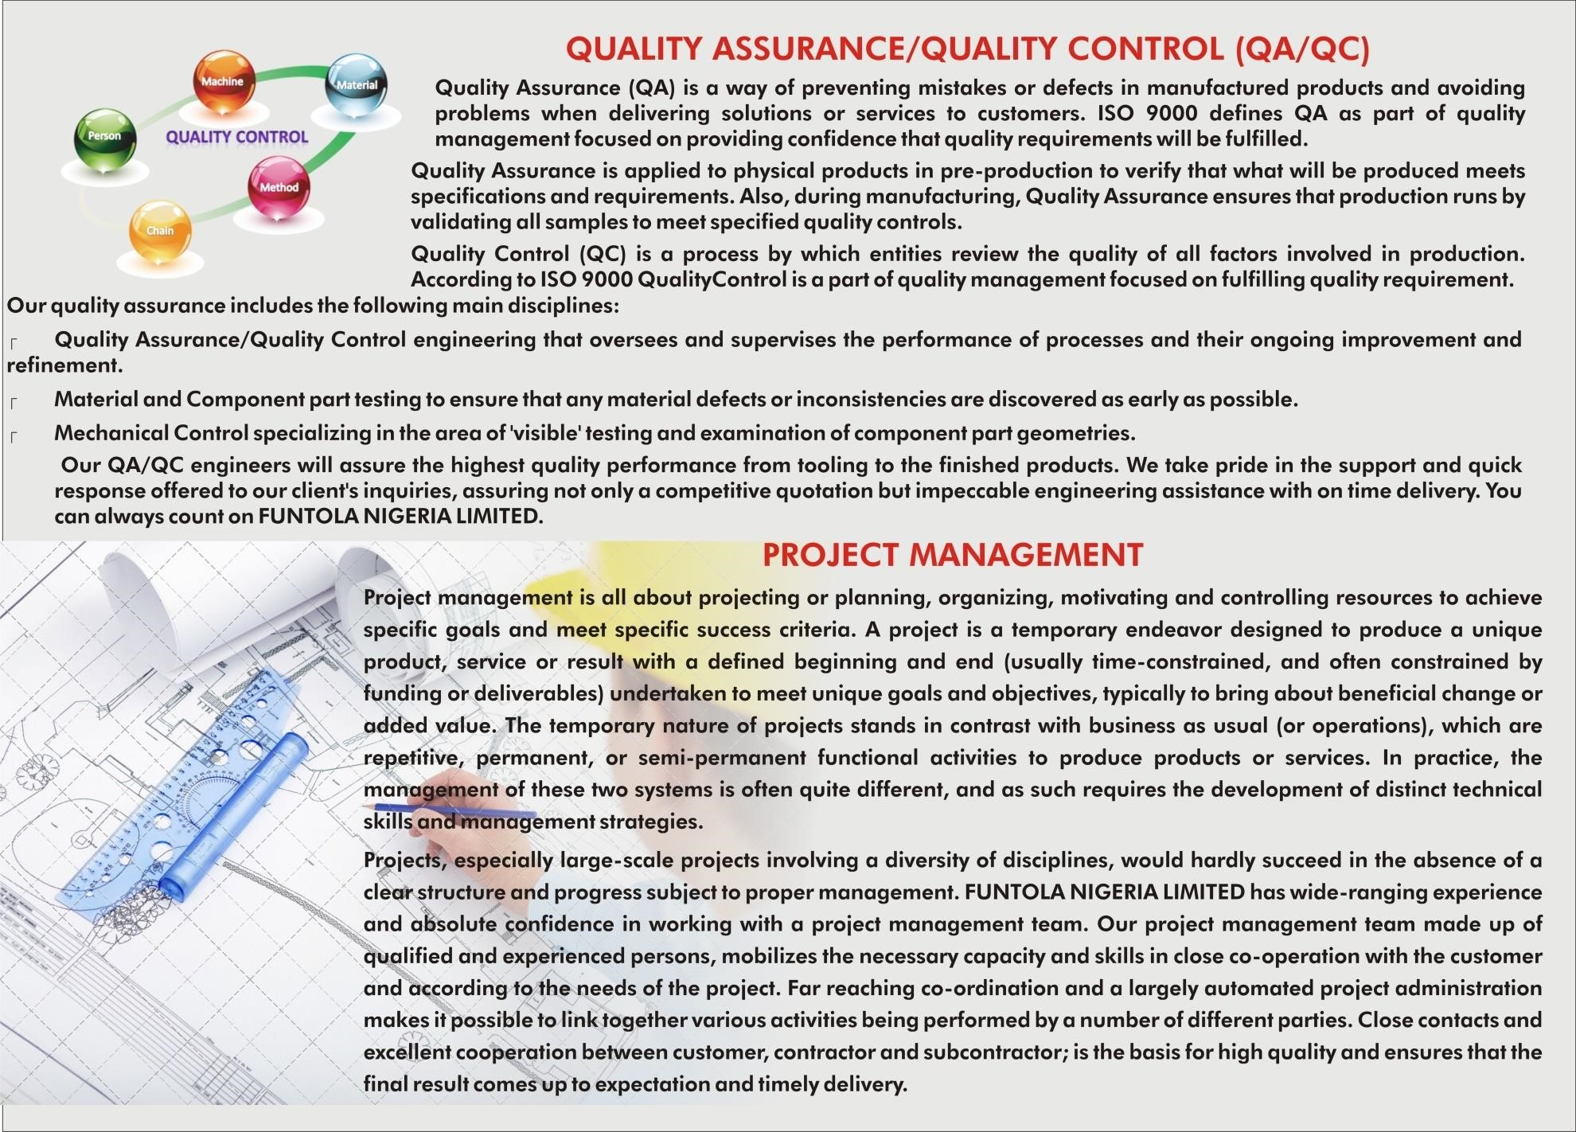
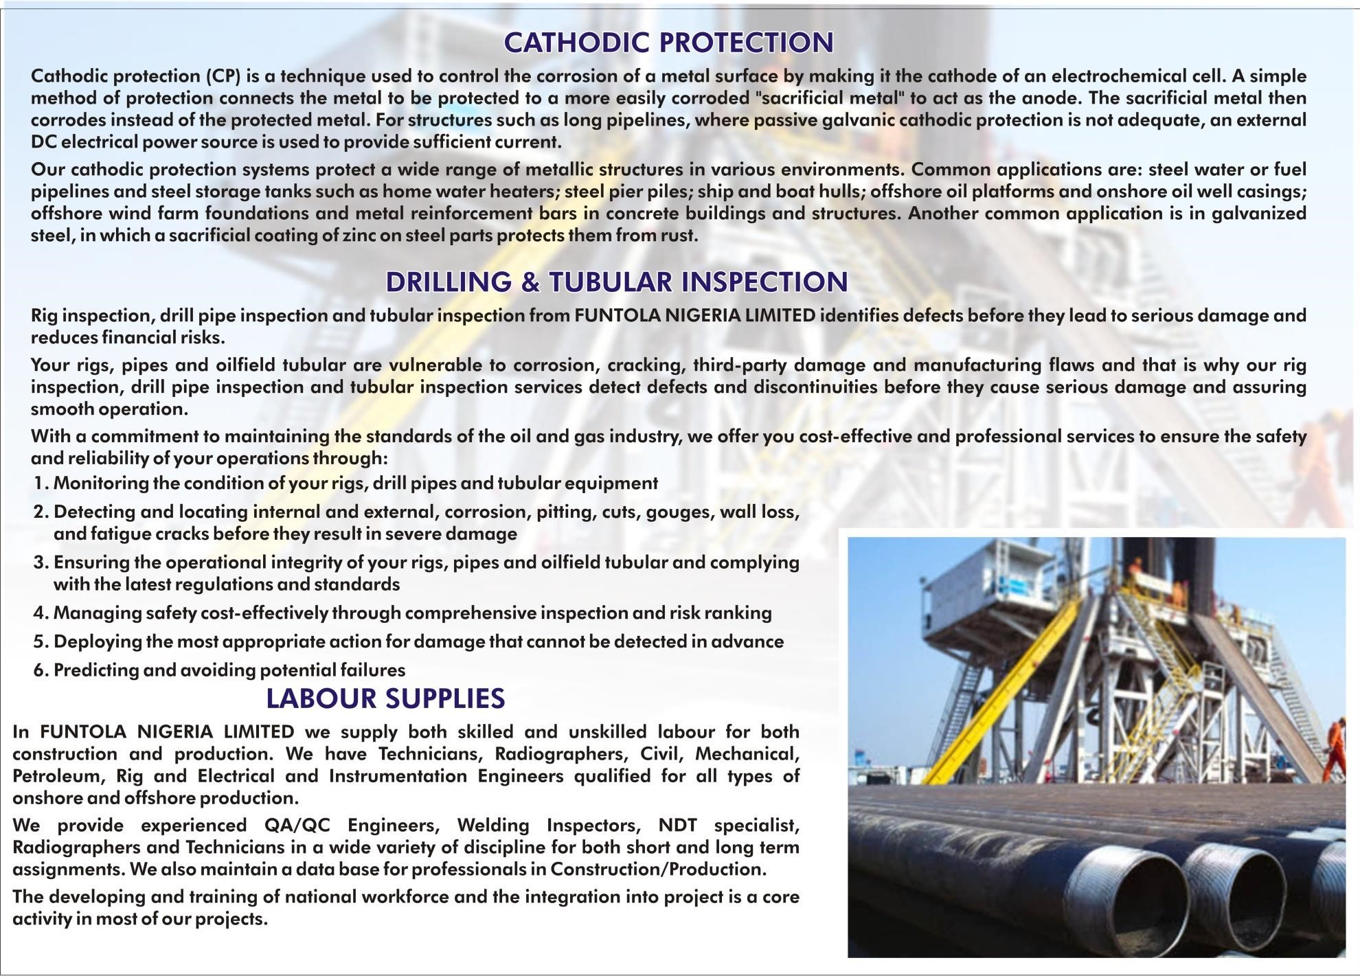


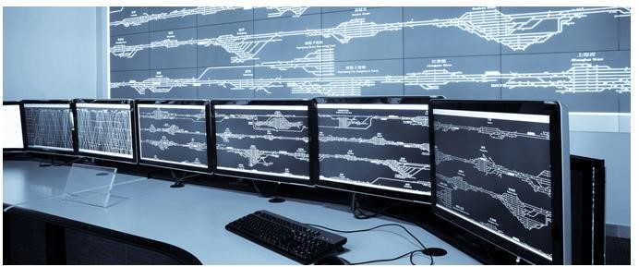




PIPELINE SECURITY AND MONITORING

System Integrator

•
Industrial Automation

•
Process Control

•
Instrumentation

•
Security Systems

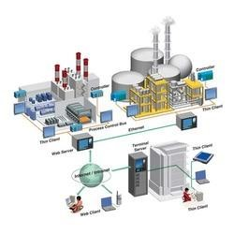




Industrial Automation

•
Instrumentation and control

•
Design and development of new systems

•
SCADA, DCS implementation for process control

➢
Automation solutions design
:

sen
sors
,

meters,motors,
valves,Pumps
,
PLC
,
SCADA

➢
Design and execution of fully
equipped electrical cabinets

➢
Software development

➢
Installation, start
-
up and
commissioning, training


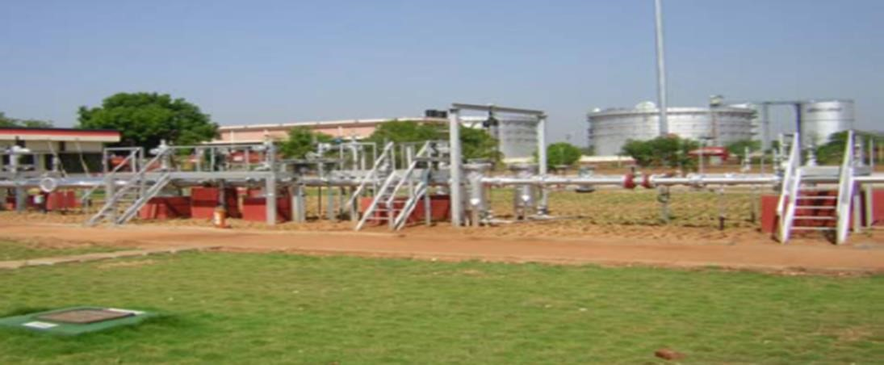

Cross
-
country Pipeline

For safe and reliable movement of
products through cross
-
country
system
&
pipelines,
requirement
of
reliable
control
telecommunication system at each station as well as at the Master
Control Station is essential to provide:

•

Efficient& safe operation of the pipeline

•

Remote monitoring
and control of the pipeline

•

Inter station communication

•

Data transfer for SCADA and PAS


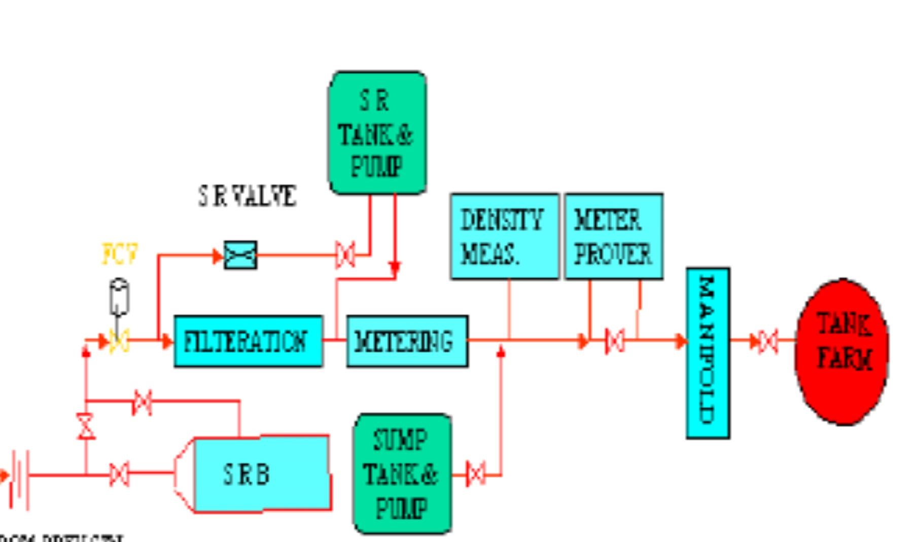

PIPELINE TERMINAL STATION

CONTROL ENGINEERING. SYSTEM INTEGRATION


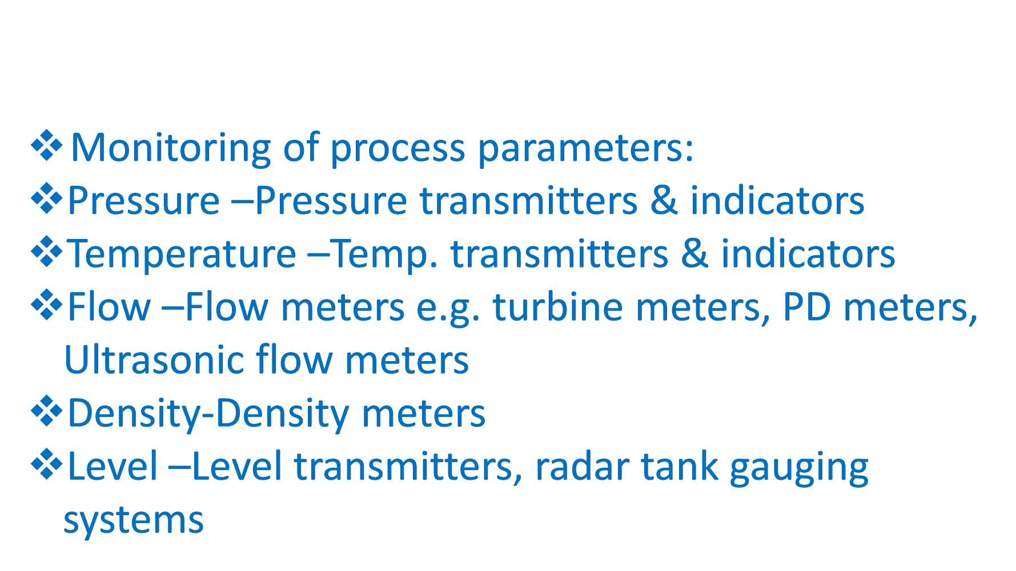

PURPOSE OF INSTRUMENTATION IN PIPELINE


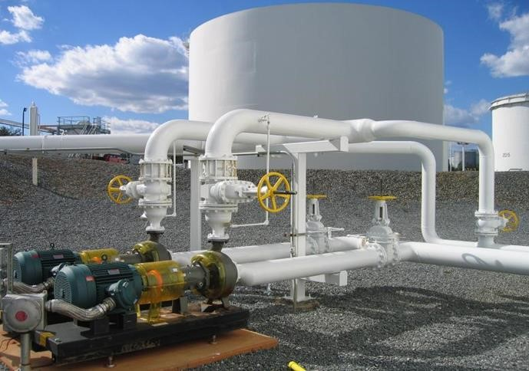
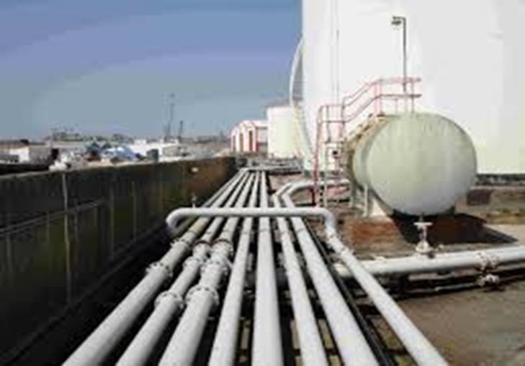
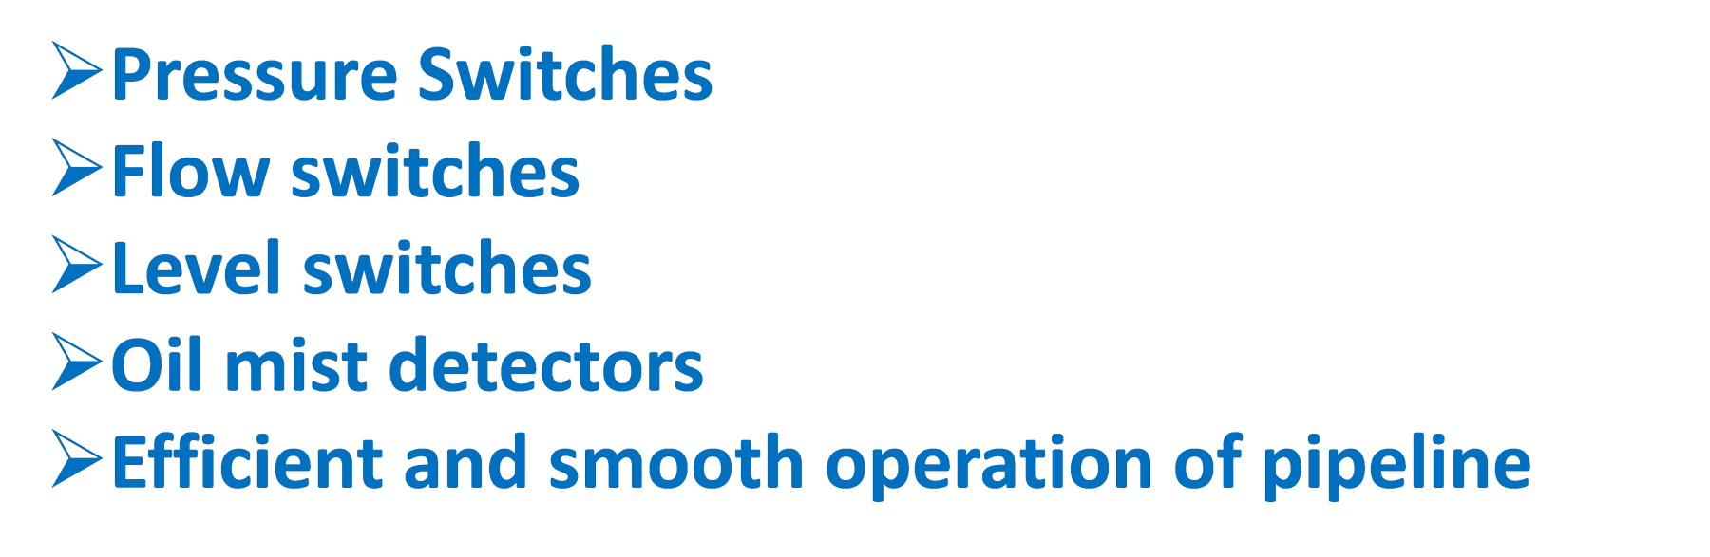

PROTECTION OF LINE
PIPE, TANKS & EQUIPMENT

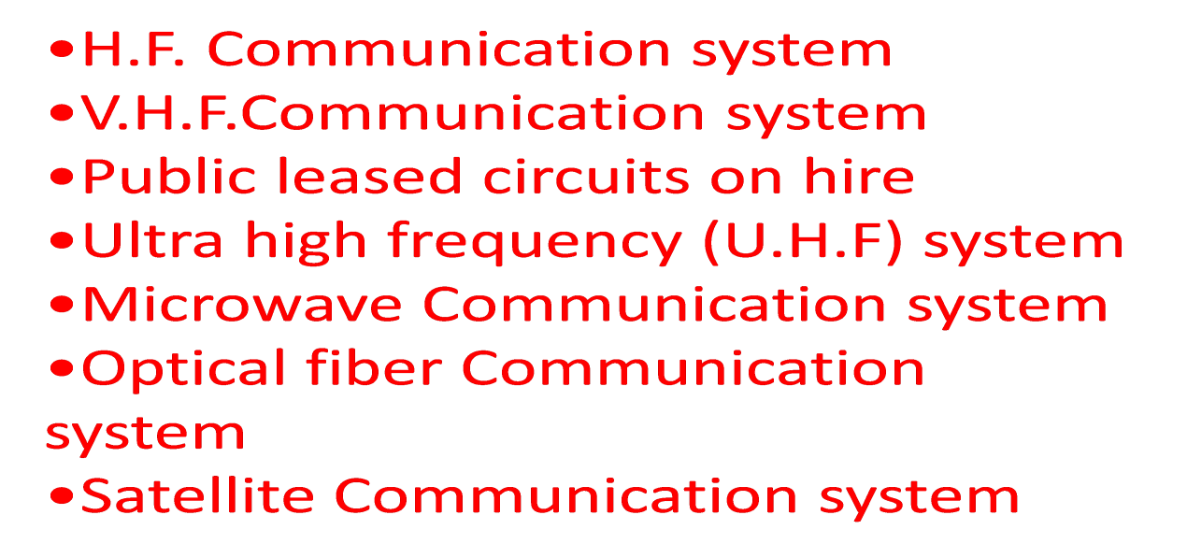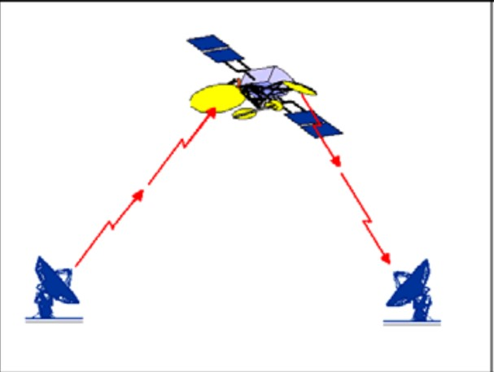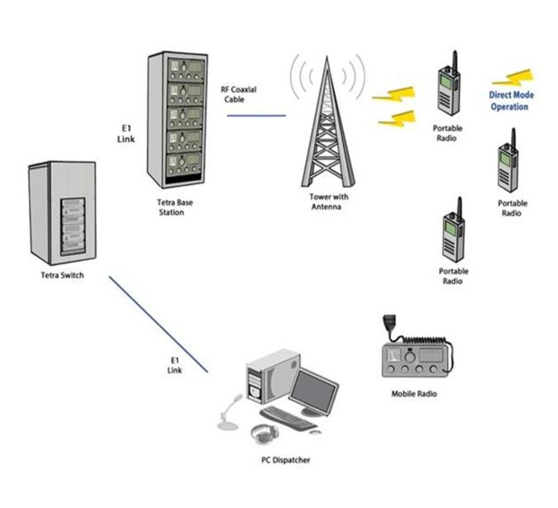

TELECOMMUNICATION SYTEMS


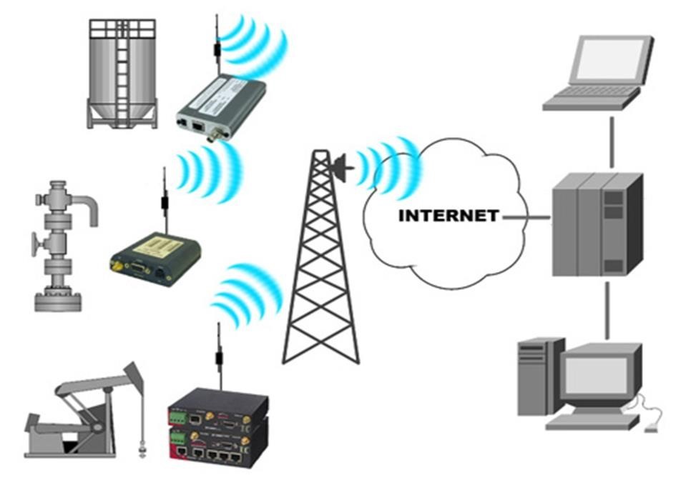
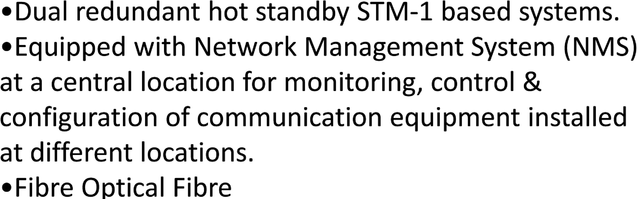

COMMUNICATION SYSTEMS IN PIPELINES

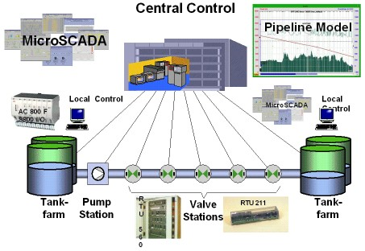

CONTROL SYSTEM IN PIPE LINE


•Highly reliable Dual redundant hot standby PLC based Control Systems having dual redundant power supplies, dual CPUs working on a dual redundant network.
•Rugged and Reliable Remote Telemetry Units (RTUs) installed at Block Valve installations for monitoring the important parameters of mainline and control.
MONITORING AND CONTROLLING STORAGE TANK VIA SCADA

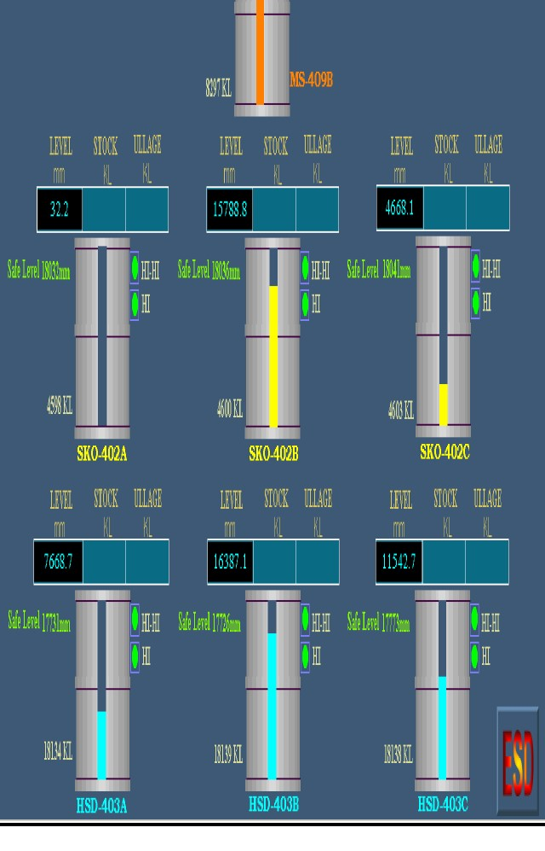

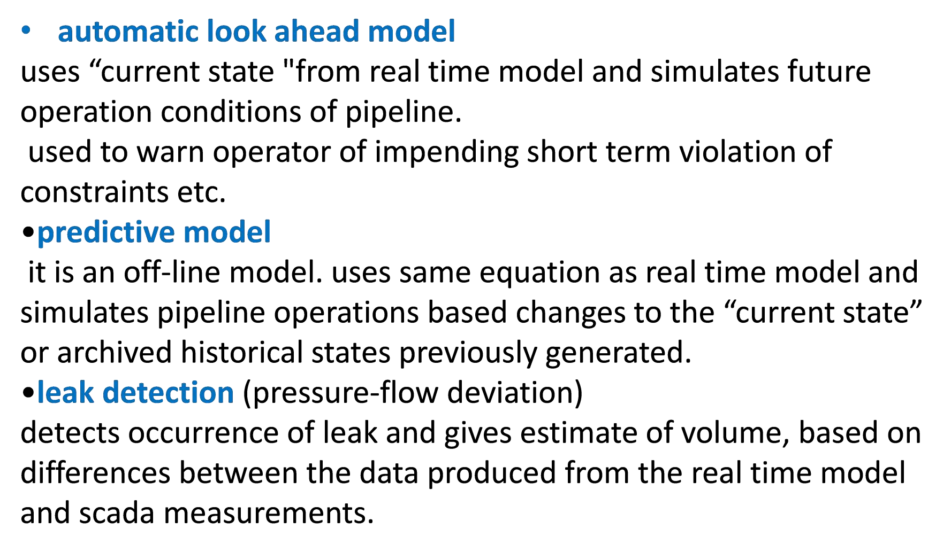

PIPELINE APPLICATION SOFTWARE


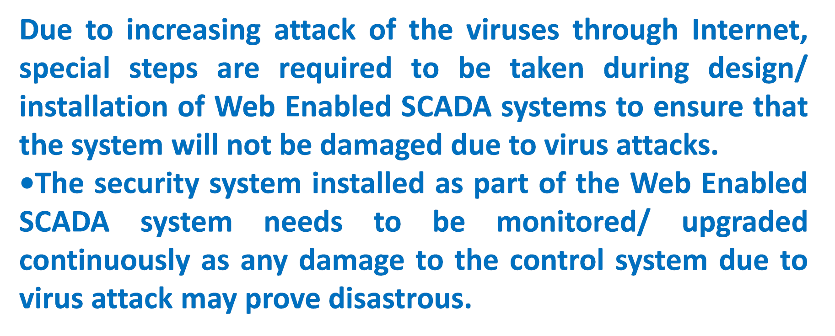

WEB ENABLED SCADA SYSTEM /SECURITY

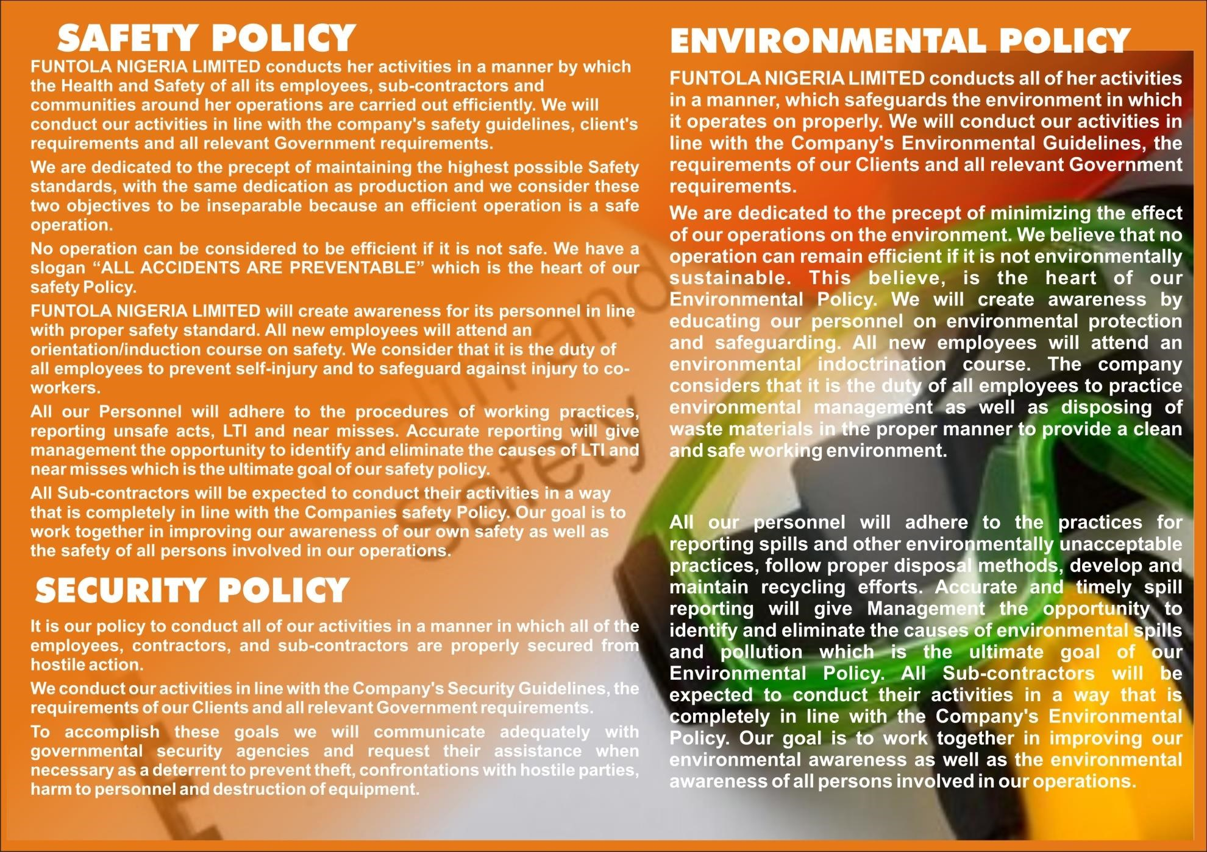

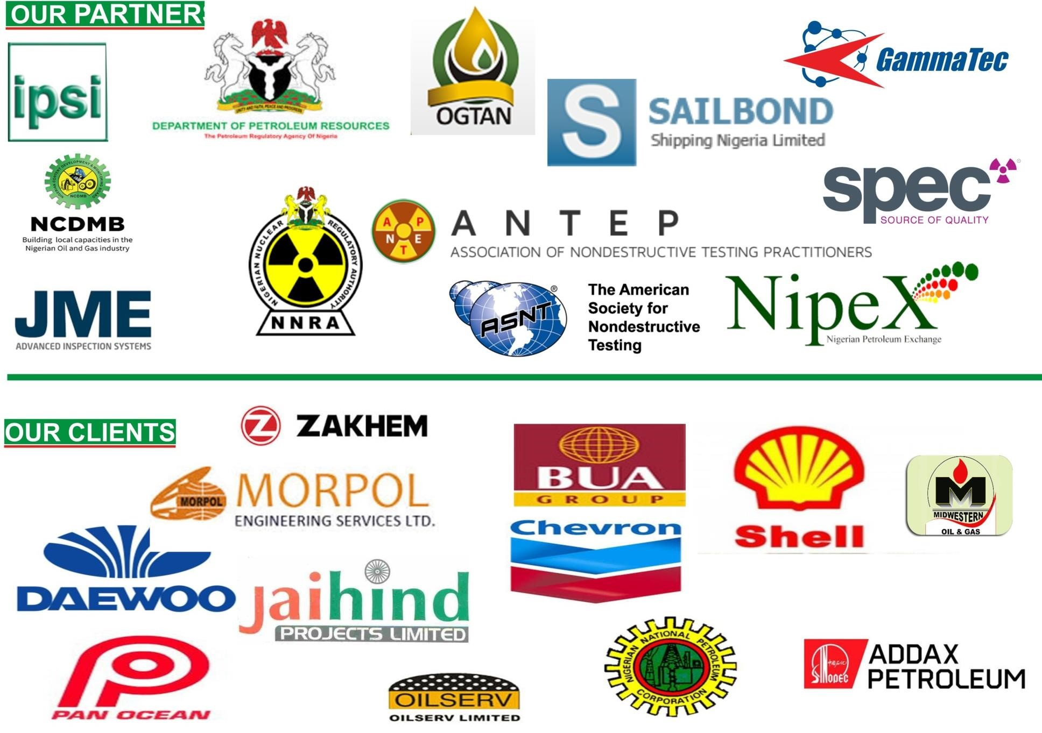

  MAJOR PROJECTS & | RECENTLY COMPLETED  SERVICES PROJECT DATE/PERIOD  NDT SERVICE 24" DIA PIPELINE EGP3A JASCON 30 PROJECT CHEVORN NIGERIA LIMITED JAN. 2010 - APR. 2010  NDT SERVICE OVADE GAS PLANT PROJECT PAN OCEAN FEB. 2009 - DEC. 2009  NDT SERVICES 20" AUCHI FLOWLINE REPLACEMENT AND CATHODIC PROTECTION MAR. 2009  NDT SERVICES IDAMA 8" LINE REPLACEMENT AUG. 2009 - JAN. 2010  NDT SERVICES NGC 24" GAS LINE CATHODIC PROTECTION 2008 - 2009  NDT SERVICE FLOW LINE CONST. 4" & 6" PANOCEAN MAR. 2007 - JUNE 2008  NDT SERVICES ULTRASONIC INSPECTION ON TANK MAR. 2006  NDT SERVICES GAS LINK FROM NAC TO FACTORY YARD BENIN 2006 - 2007  NDT SERVICES VARIOUS CHEVRON NIGERIA LIMITED PROJECT FEB. & CONST. 2005 - TILL DATE  NDT SERVICES VARIOUS CHEVRON PROJECT 2005 - TILL DATE  NDT SERVICES SPDC VARIOUS PROJECT 2005 - 2007  NDT SERVICES PLANTFORM PETROLUEM PIPELINE UMUTU TO KWALE PROJECT 2005 - 2006
S/N | CLIENT NAME
1 | WEST AFRICAN VENTURE
2 | GRAMEN PETROL SERVICES
3 | NGC
4 | GREDRO NIGERIA LIMITED
5 | DEWAYLES INTERNATIONL COMPANY
6 | HENSTEEL ENG. & CONST.
7 | PAN-OCEAN
8 | GUINESS COMPANY
9 | BABLINK RESOURCES LTD.
10 | JEM TECHINICAL GLOBAL ENG. SER. CO  LTD.
11 | DEWAYLES INTERNATIONL COMPANY
12 | BABLINK RESOURCES LTD.

13 | LAVON NIG. LTD. FOR SPDC | NDT SERVICES | VARIOUS LOCATION | JAN. 2004 - 2005
14 | IDMAN ENG. & CONST. | NDT SERVICE | VARIOUS CHEVRON PROJECT FAB &  CONST.INCLUDING EGP313 | 2003
 | IDMAN ENG. & CONST. | NDT SERVICE/  CATHODIC  PROTECTION | PLANTFORM PETROLUME LIMITED
15 | WECO ENGR. & CONST. SERV. LTD | NDT | VARIOUS CHEVRON NIGERIA LIMITED | 2009
16 | PERRYBELL | NDT | O.A.G.M | 2009
17 | NAPERE | NDT | O.A.G.M | 2009
18 | NEST OIL FOR SPDC | NDT SERVICES | RADIOGRAPHIC INSPECTION | 2003 - 2005
19 | ROYAL OIL/HUTES ENGINEERING AND  CONSTRUCTION LTD. SPDC 2004 | NDT SERVICES | LABOUR SUPPLY AND CATHODIC  PROTECTION | JUN 2003 - MAR. 2004
20 | MARCH TO VICTORY (MTV) FOR SPDC | NDT SERVICES | OTUMARA GAS LINE AND PUMP UNITS | SEPT. 2003 - FEB. 2004
21 | BAYWOOD CONTINENTAL LTD. | NDT SERVICES | EGWA I & II SPDC FLOWLINE CONST. | 2002 - 2005
22 | PINE OIL FOR NNPC - PPMC LOADING UNIT | NDT SERVICES | RADIAGRAPHIC INSPECTION AND DPI | AUG. - OCT. 2002
23 | SUPERTECH - NNPC PROJECT | NDT SERVICES | RADIAGRAPHIC INSPECTION ON NNPC  WATER LINE | SEPT. 2002 - OCT. 2002
24 | DECK-OIL & GAS FOR SPDC | NDT SERVICES | RADIOAGRAPIC INSPECTION | NOV. 2002 - FEB. 2003
25 | PAN-OCEAN | NDT SERVICES | RADIOGRAPHIC INSPECTION OF VARIOUS  DIAMETER PIPES | DEC. 2002 - JAN 2004
26 | DBN-NEPA PROJECT | NDT SERVICES | EGBIN POWER STATION | JULY 2001 - MAR. 2002
27 | LUMANN NIG. LTD. ARCO  PETROCHEMICAL/SPDC | NDT SERVICES | THICKNESS CHECK , MPI, TEST AND  RADIOGRAPHY INSPECTION(NDT TEST) | JULY 2001 - 2002

28 | ANOTECH GLOBAL SERVICES | NDT SERVICE | PIPE LINE CONST. UMUTE; 6" KWALE 8" & 16"  PIPE | MAY 2007 - JAN. 2008
29 | BAYWOOD CONTINENTAL LTD. | NDT SERVICES | CHEVRON NIGERIA LIMITED TANK REPLANT  ESCRAVOS TANK FARM | FEB. 2008 - AUG. 2009
30 | ALLIED INSPECTION SERVICES LTD. | NDT SERVICES | VARIOUS CONTRACTORS SPDC/TEXACO  PROJECT | MARCH 2007
31 | MORPOL | NDT SERVICES |  | 2007
32 | HURLEG | NDT & CP | NNPC/NGC | 2004
33 | PYTHON ENGINEERING | MARINE PAINTING  & SCAFFOLDING | BUILDING OF SHIPS | 2010
34 | SEA TRUCKS GROUPS OF COMPANIES | MARINE PAINTING  & WATER  BLASTING | JASCON 30 MAINTENANCES  JASCON 29 MAINTENANCES  JASCON 23 MAINTENANCE | 2010
35 | DEACON | MARINE PAINTING | LAYBARGE AND HOUSE BOAT | 2010
36 | GREDOR | MARINE PAINTING | LAYBARGE AND HOUSE BOAT | 2010
37 | WEST MINISTER DREDGING & MARINE | SCAFFOLD &  WATER BLASTING | OLERO GREEKS FLOATING FLOWSTATION  MAINTENANCES | 2010
38 | JEMTECH ENGINEERING | SCAFFOLD | NNPC/NGC WARRI STORAGE TANKS | 2010
39 | HENSTEEL ENGINEERING | SCAFFOLD | AGBAMI PROJECT | 2010
40 | INDORAMA | NDT | INDORAMA GAS PIPELNIE AND ELEME PETROCHEMICAL PLANT | DEC. 2015
41 | BUA GROUP | NDT | OB3 DIA 48" X25KM GAS PIPELINE OBEN - NODE GAS TREATMENT | AUG. 2016

ONGOING PROJECTS
 |  |  | PLANT (GTP)
42 | SEPLAT | NDT | ESCRAVOS TO LAGOS PIPELINE (ELP)PHAES II (36" line) | JUNE 2016
43 | BUA GROUP | NDT | BUA EDO GAS PIPELINE (29KM LINE)  AND FACILITY | 2015
44 | MORPOL ENGINEERING | NDT | GBARAN-UBIE INFILL PROJECT 2 (12”  Line) | 2016
 | SEPLAT | NDT | CONSTRUCTION OF AMUKPE/OVHOR BULKLINE | 2020
45 | SEPLAT | NDT | REPLACEMENT OF WELL 28T FLOW-  LINE PROJECT | 2021
46 | BETA GLASS PLC | MPI/PT | STRUCTURAL INSPECTION OF MASTS | JULY 2021

• NEW CROSS/ANOTECH PROJECT: EFE EVALUATION PIPE LINE PROJECT OML FIELD, (OGHARA/MOSOGAR) PAN OCEAN

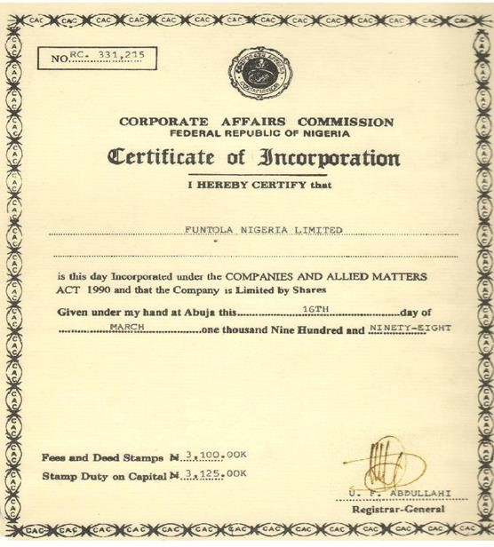
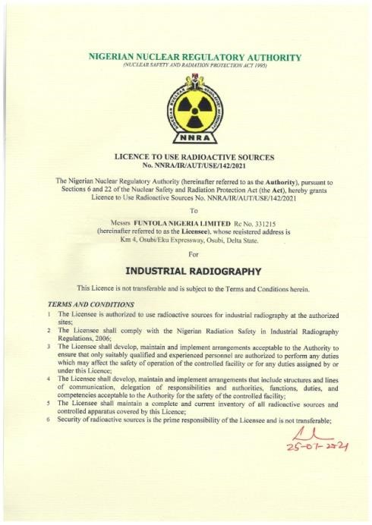
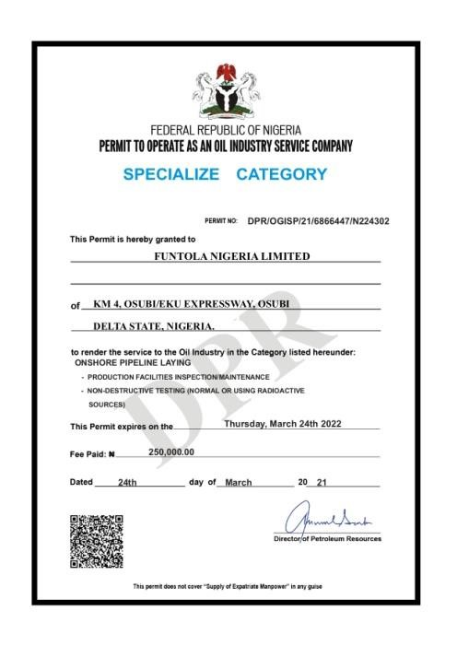
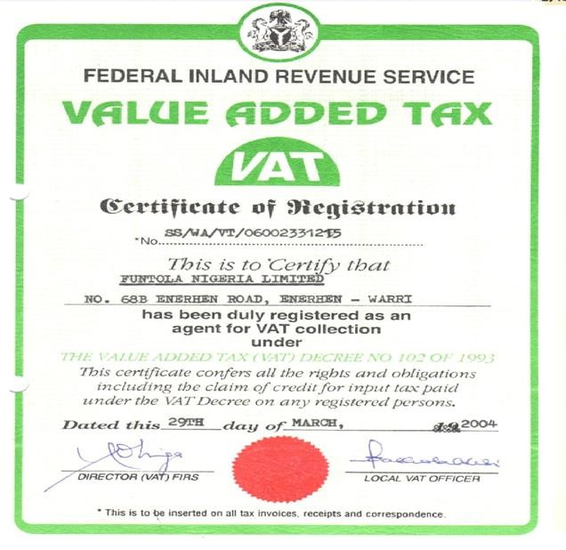
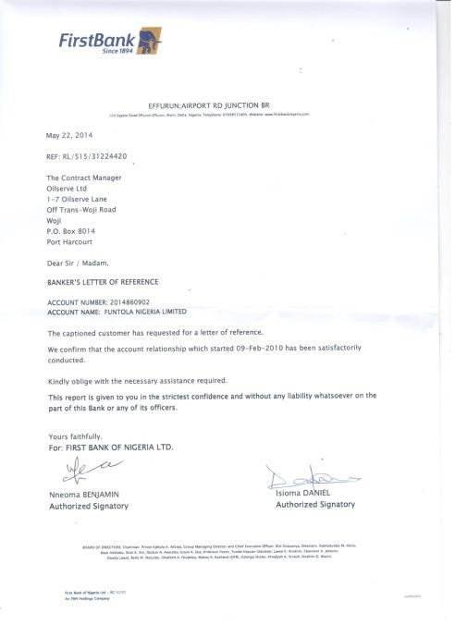
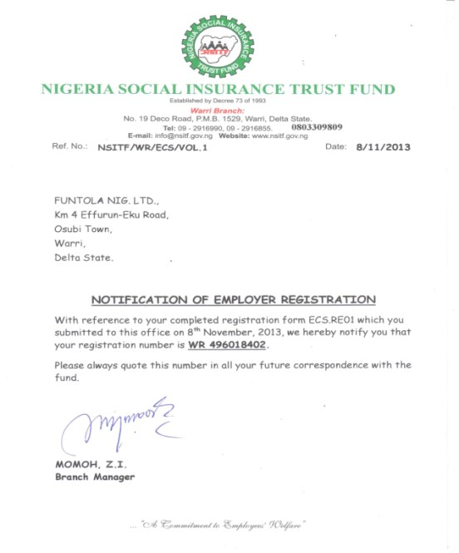

PROFESSIONAL CERTIFICATES AND LICENCES







For more information

Visit Us

@

www.funtolaglobal.co
m

OFFICE ADDRESS:
KM 4, EFFURUN/EKU ROAD, OSUBI TOWN, DE
LTA STATE.

+234(0)8064402577, +234(0)80266001

EMAIL ADDRESS:
funtolandtnigeria@gmail.com
,
funto_nig@yahoo.com

